
GIS Library Tutorials – Introduction to ArcGIS Online – 10

To share your map or embed it on a website
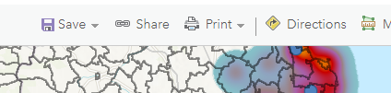
The default is that your map is private
Left click on Share

This window opens:
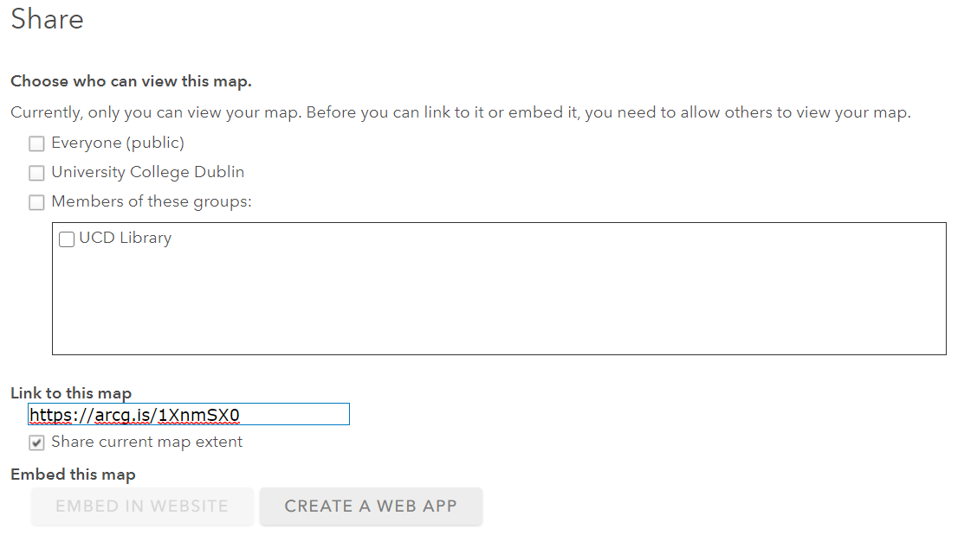

Left click in the checkbox for the audience you will allow view your map, e.g., everyone in your organisation – in this case it is University College Dublin
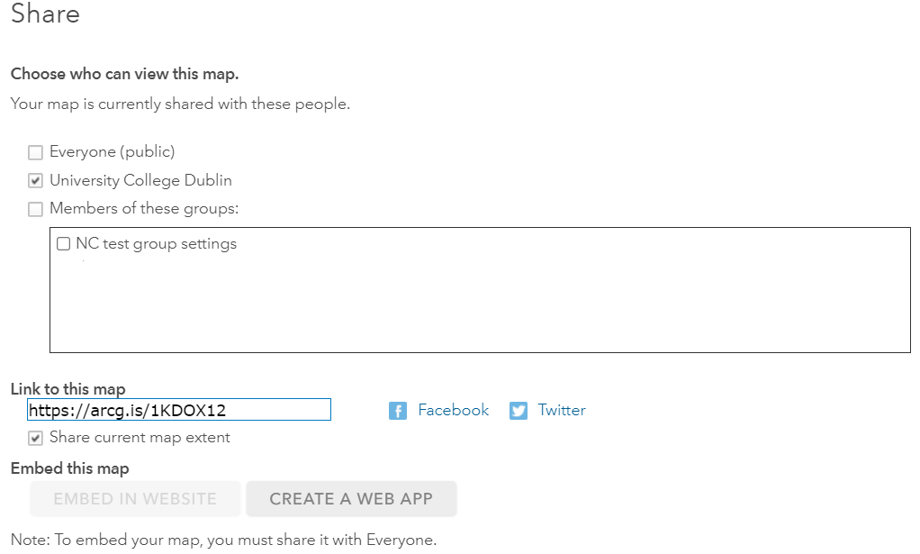

You will then see that several of the data layers you have added need to be shared. Otherwise, these will not be visible to UCD people viewing your map.

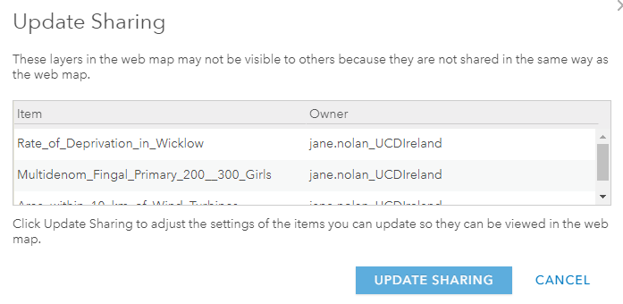
Scroll down the page and left click on Done 

To embed the map on a blog or website, you must tick the checkbox next to Everyone (Public)

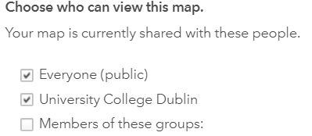

This new message pops up, left click on OK
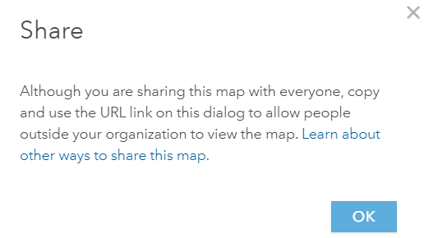

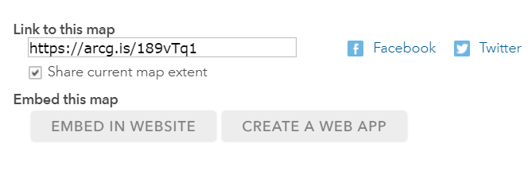
This allows you copy the link which you can email to anyone you wish.

If you click on EMBED IN WEBSITE you will get the code to use to embed your map into a website or blog
Firstly, select options for your map and then copy the HTML provided
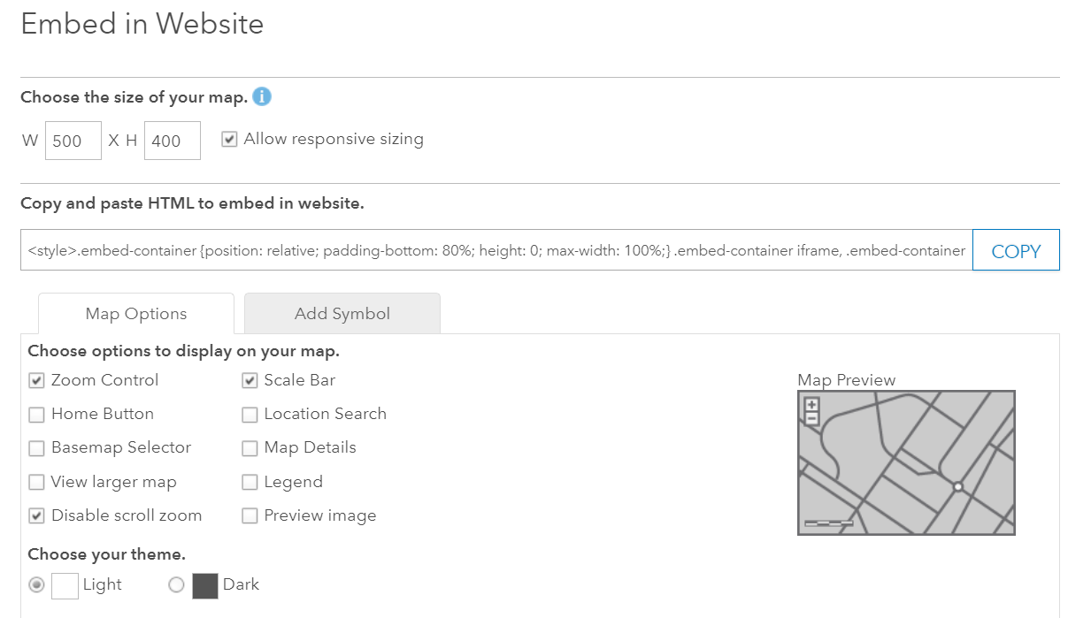

Then click on DONE

To edit your Shared settings, for example, to change your audience for a specific map
Go to your Content section – left click on Home and then left click on Content

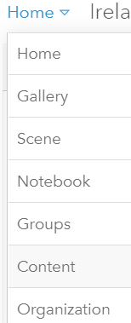
This lists all of the maps and layers you have created. A query which you have previously run and saved can be used another time – it will be named as a Feature Layer and can be imported into a new map

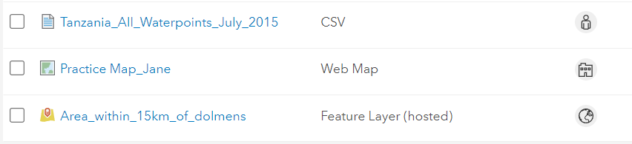

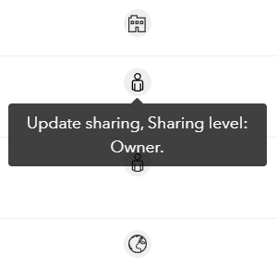
The globe icon tells you that the map is public and shared with Everyone
The person icon tells you that only the owner can view the map
The building icon tells you that anyone in your organisation can view the map

Left click on an icon next to a Feature Layer to change its sharing permissions

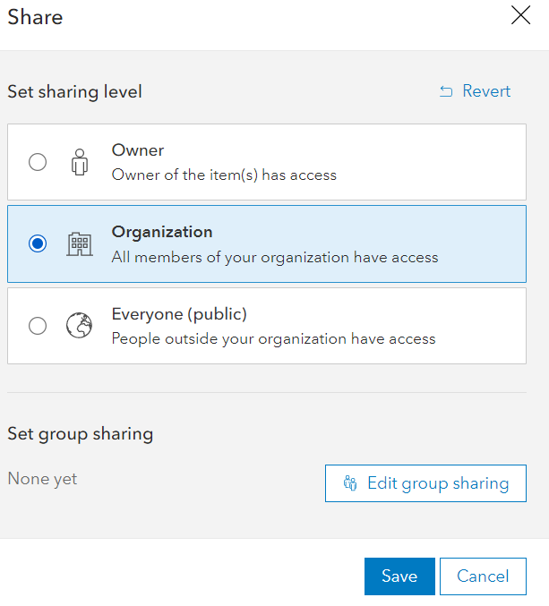
Left click in the radio button to choose the audience you wish to share your map with
Left click on Save

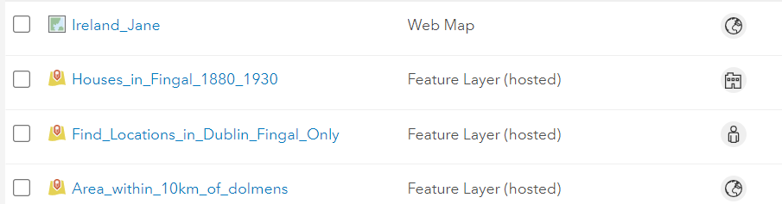

Help and Details about sharing, etc are available at https://doc.arcgis.com/en/arcgis-online/share-maps/share-items.htm

You can set up a GROUP to share maps with, e.g set up the group and invite collaborators to it – e.g. a group of students, or a research group. Think about whether you want everyone to have editing rights, etc
See more here: https://doc.arcgis.com/en/arcgis-online/get-started/get-started-with-groups.htm

You can delete / move / share layers, maps, etc when you left click in its checkbox
